

UNITEDWORLD INSTITUE OF TECHNOLOGY

(UIT)

Summative Assessment (SA)

Submitted BY

Patel Zalak Bipinkumar

(Enroll. No.: 20220701020)

**Course Code and Title:**

**[IBM]**

B.Sc. (Hons.) Computer Science

IV Semester – December – May 2024

**UIT**

March/April 2024

Contents

Project Title 2

Aim 3

Dataset Description 3

Project 4

Preprocessing Data 5

Data Visualization 6

Model Implementation 12

Conclusion 17

# 

# Project Title:

Forest Fire Prediction

# Aim:

The main purpose of this project on Forest Fire Prediction is to Predict using image data whether it is a fired image or a non-fired image. The model will be trained using CNN to predict accurate results on Forest Fire which can be useful in real-time for forest officers to care for dense forest regions.

# Dataset Description:

Dataset is taken from Kaggle

<https://www.kaggle.com/datasets/phylake1337/fire-dataset>

This Dataset was used to train the model for predicting accurately.

About Dataset: The data is separated into two folders: non-fire_images, which has 244 nature images (such as forests, trees, grass, rivers, people, foggy forests, lakes, animals, roads, and waterfalls), and fire_images, which has 755 outdoor fire photos, some of which include significant smoke.

<https://www.kaggle.com/datasets/atulyakumar98/test-dataset>

This Dataset image is used in our project to test the accuracy of model on unseen data.

# 

# Project:

**Importing necessary libraries**

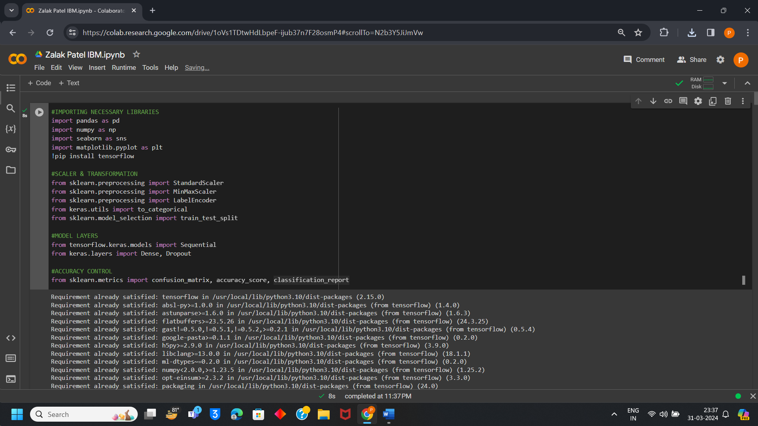

**Importing Dataset**

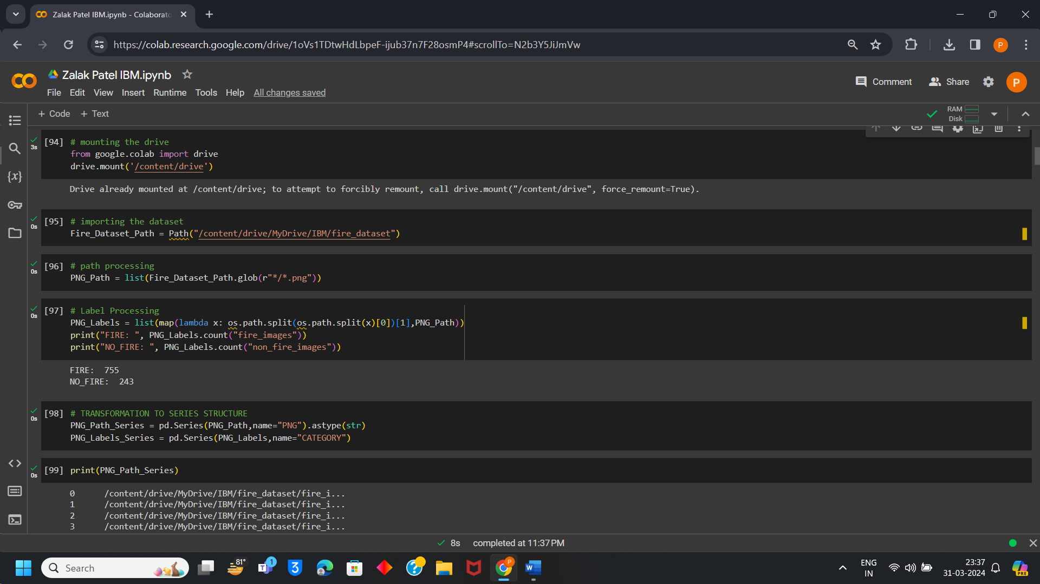

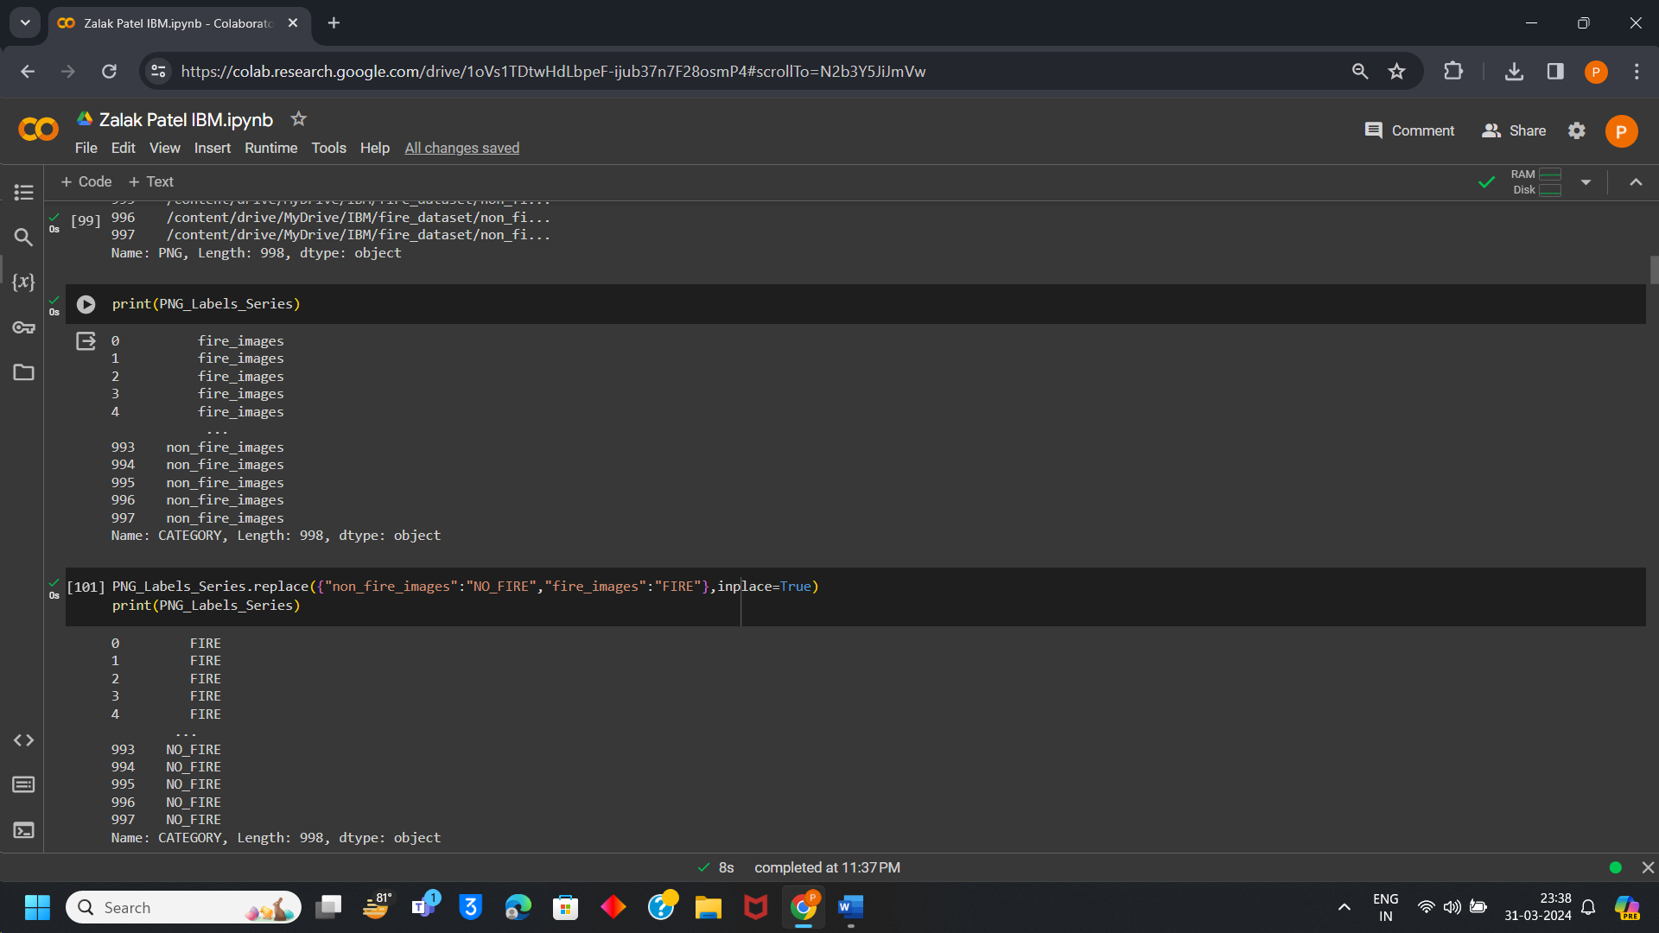

# Preprocessing Data:

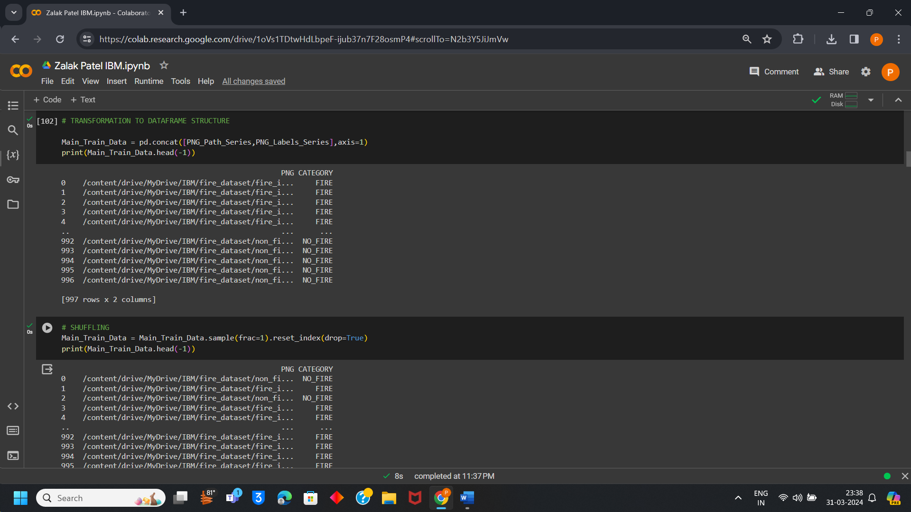

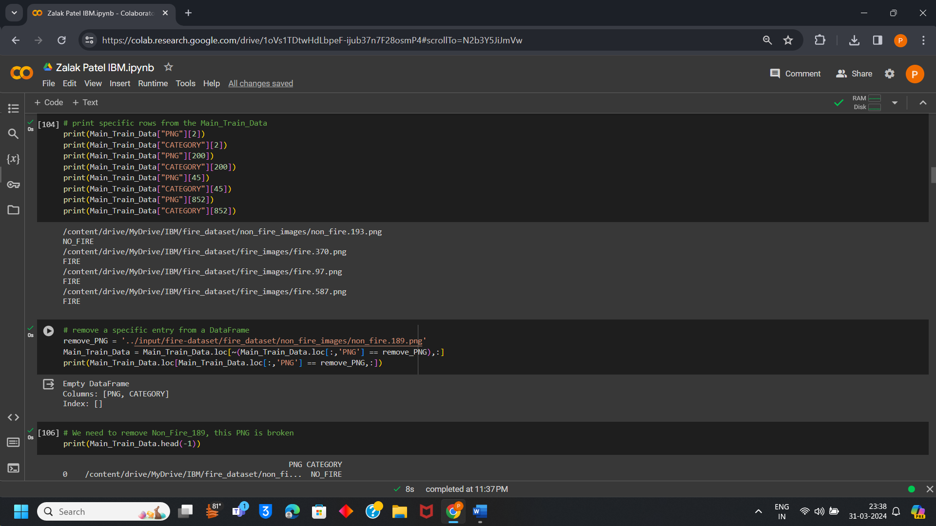

# Data Visualization:

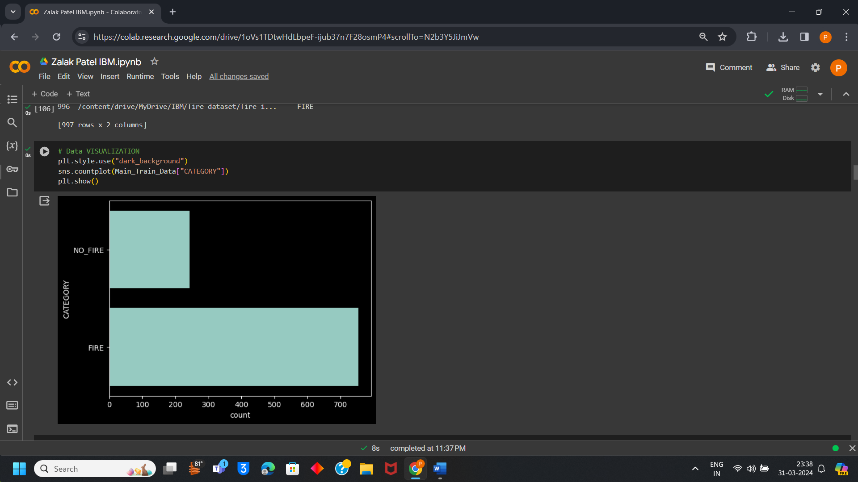

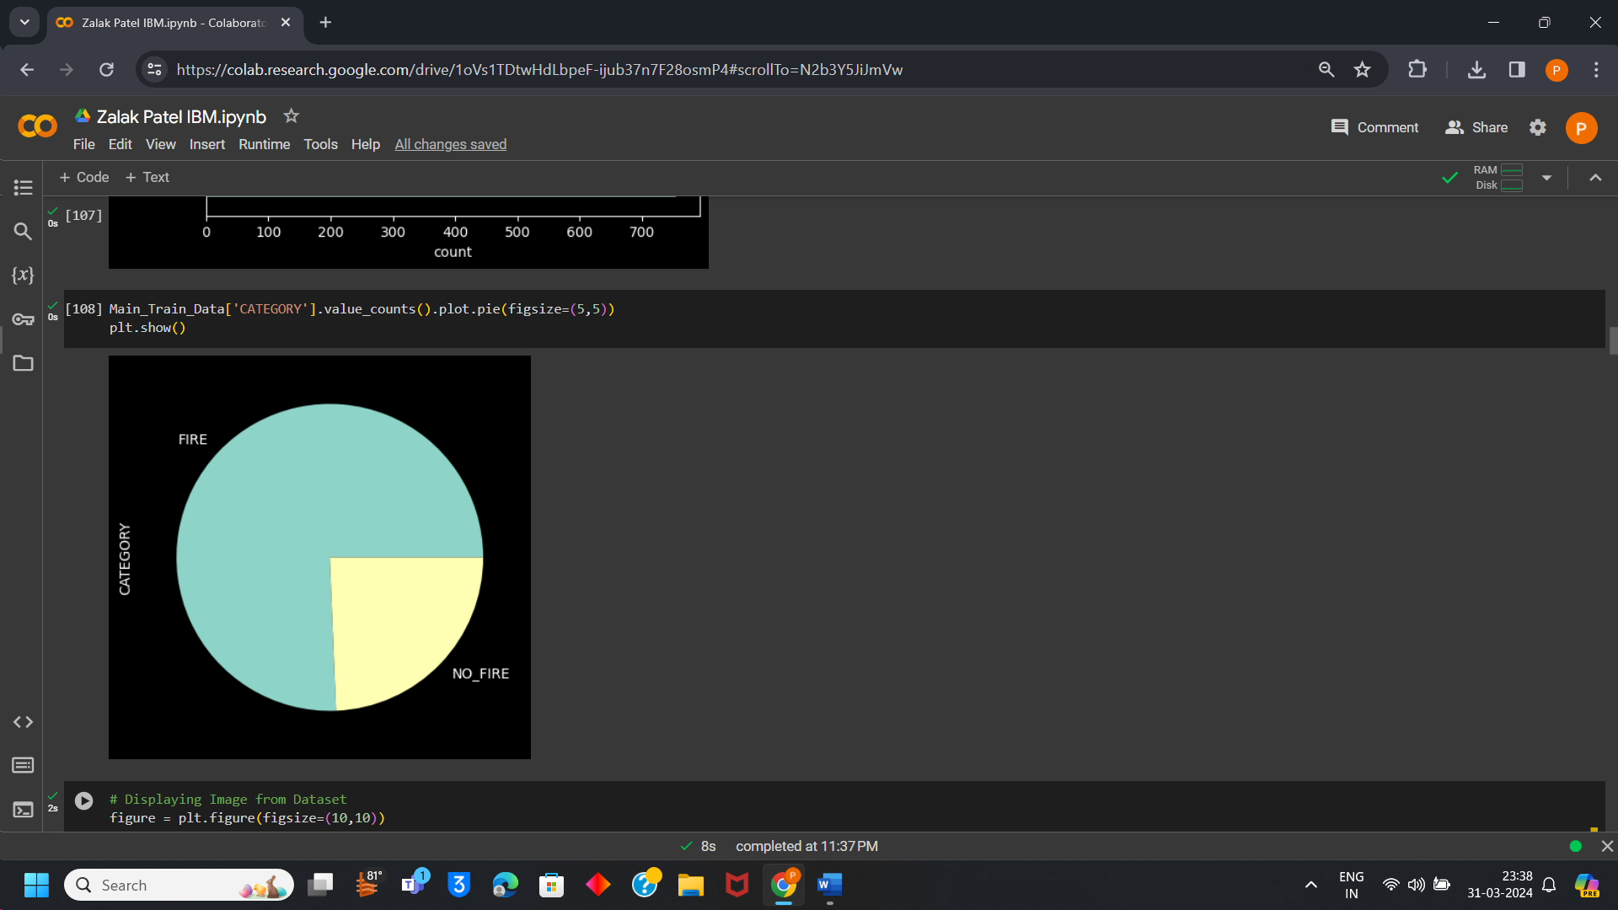

**Few Images from Dataset:**

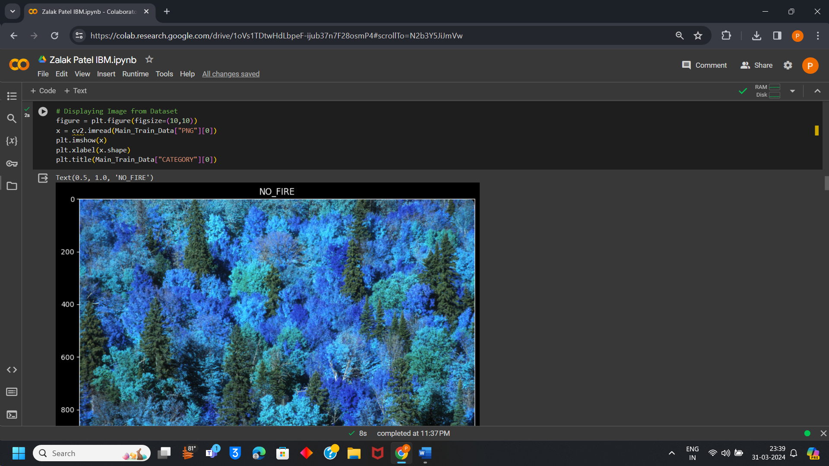

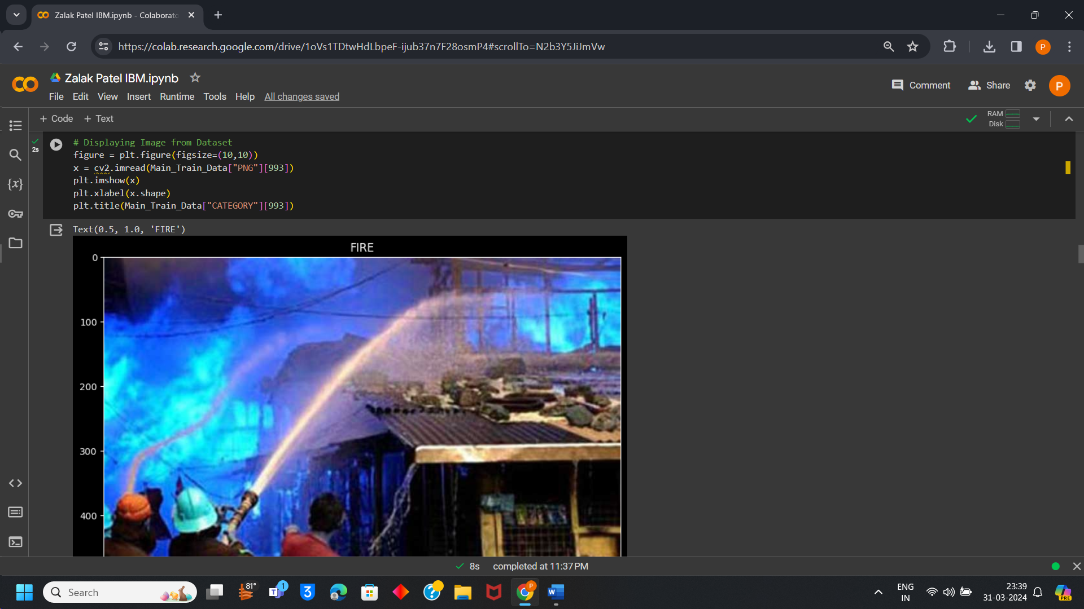

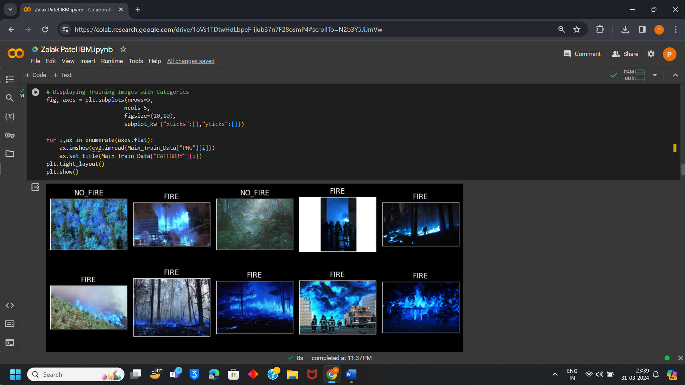

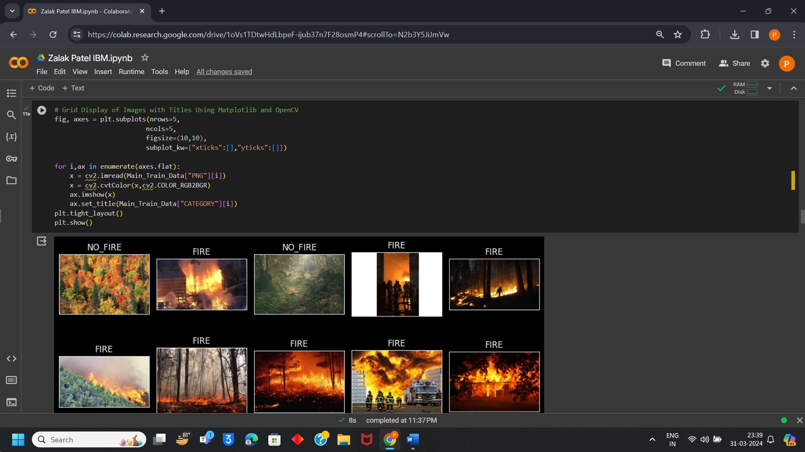

**Train and Test Split from Data:**

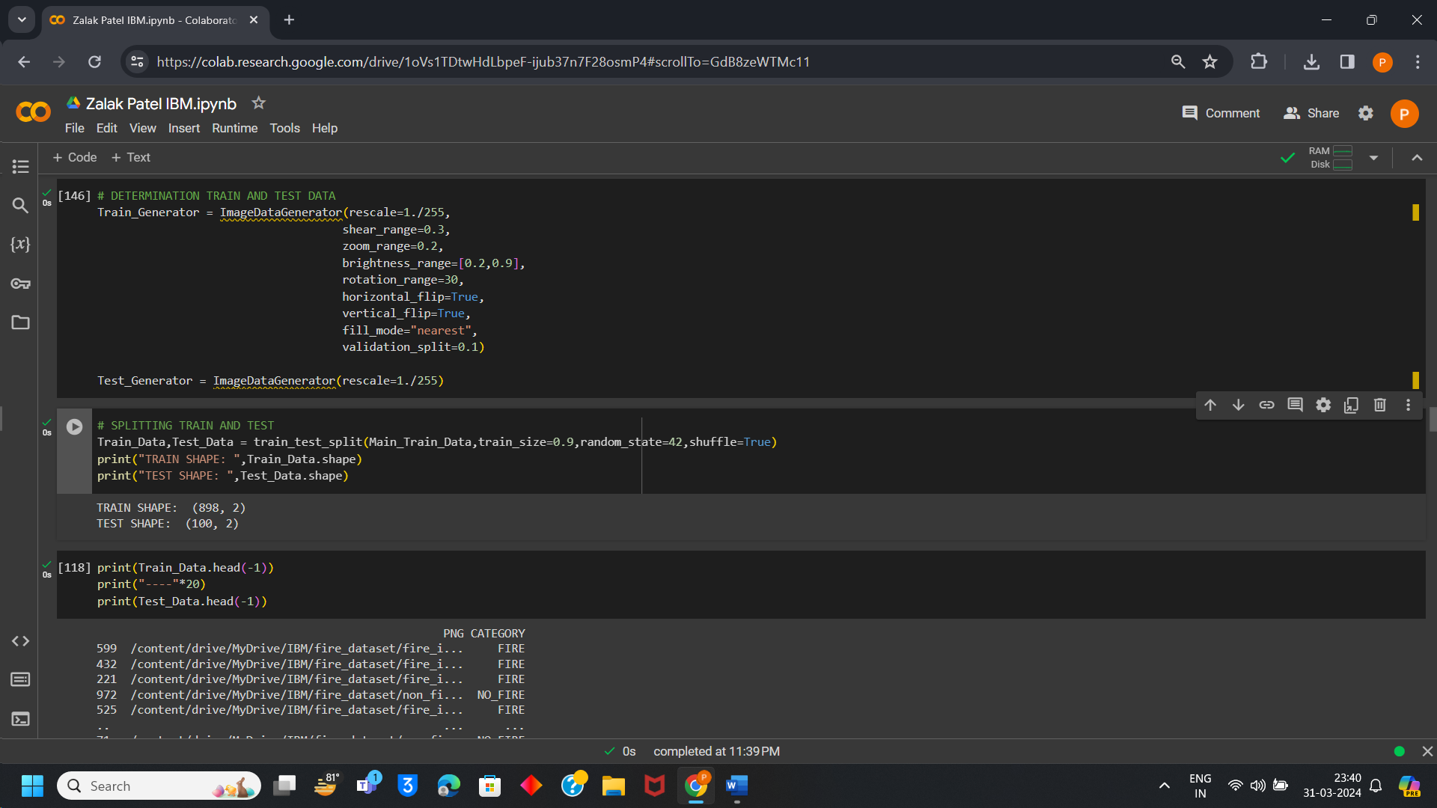

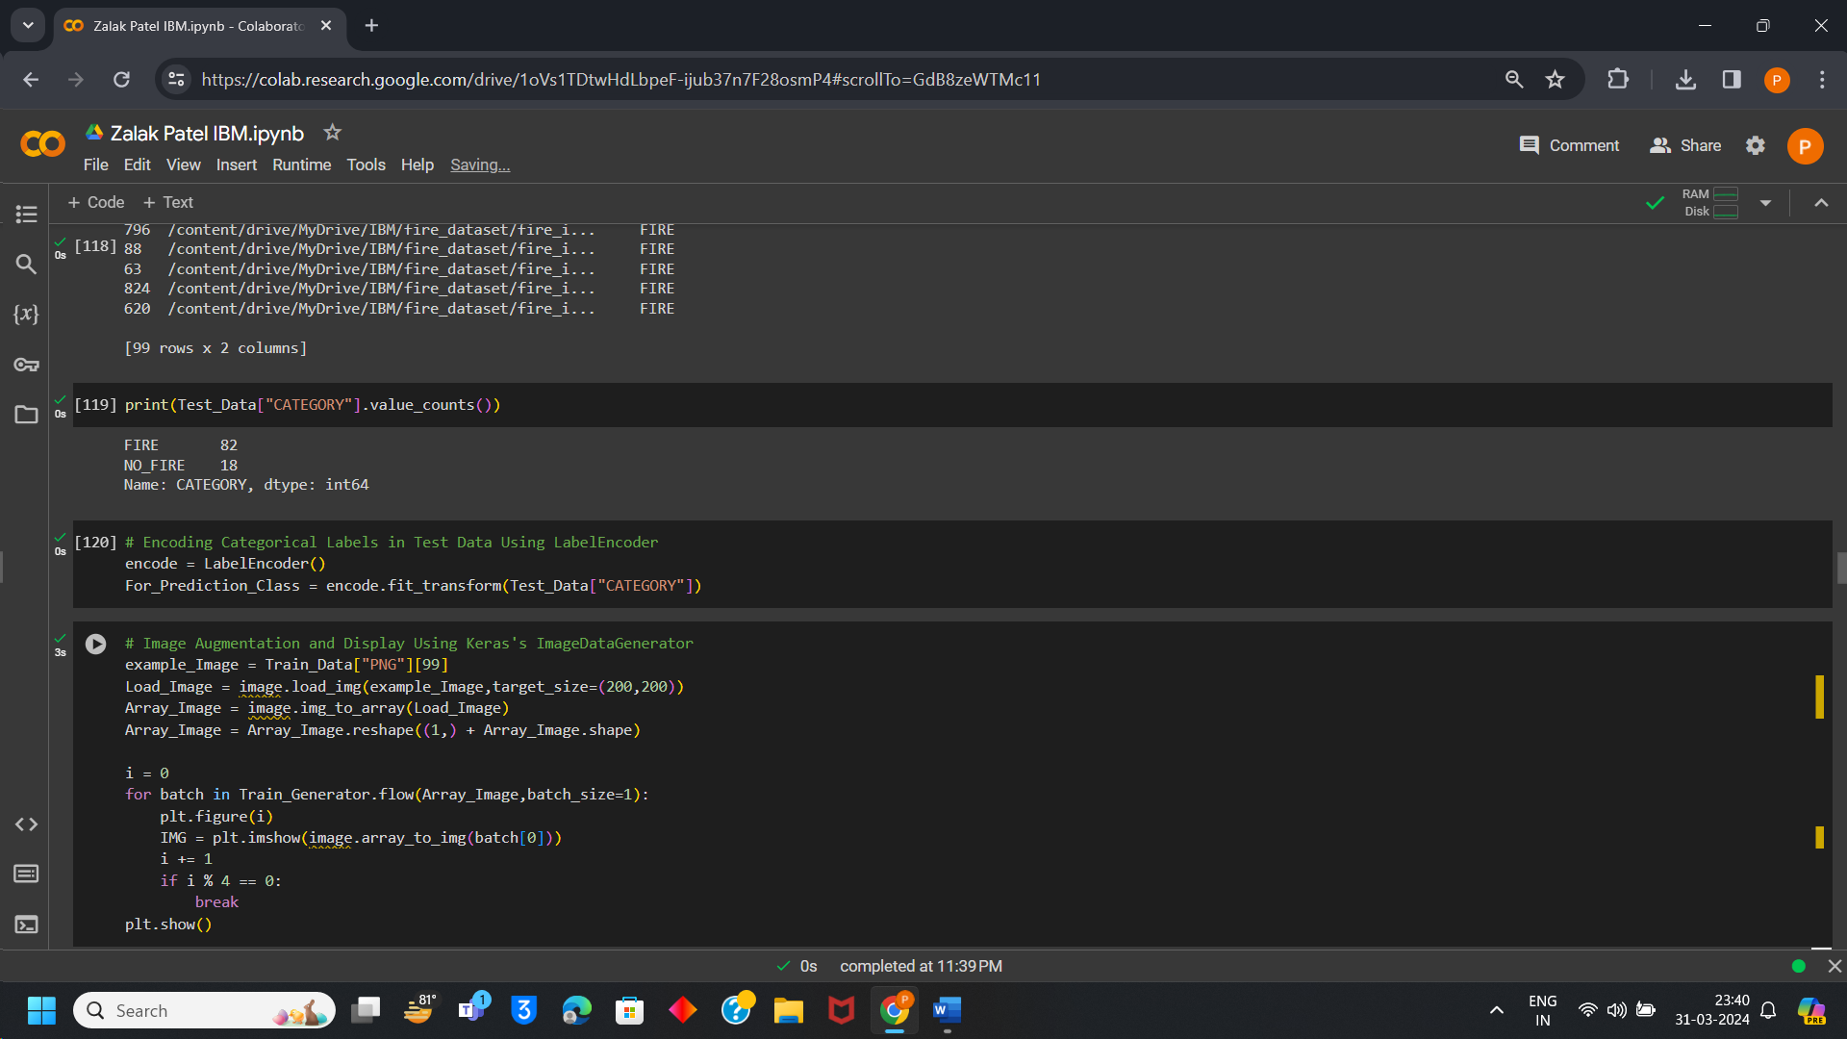

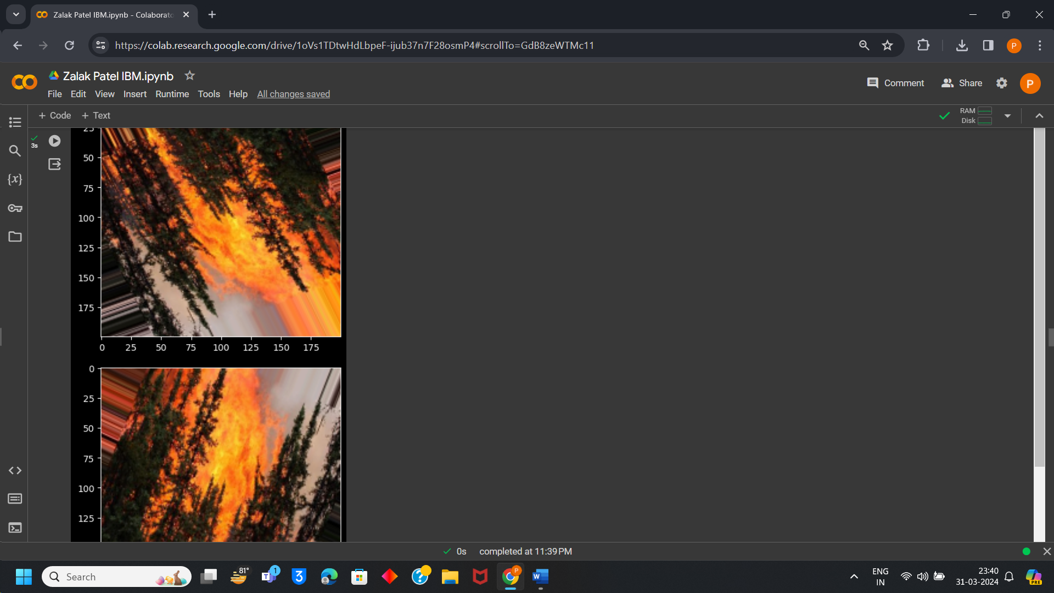

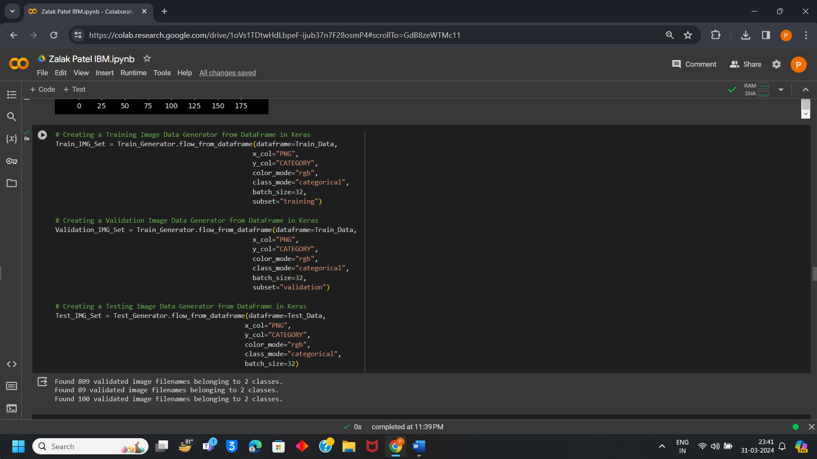

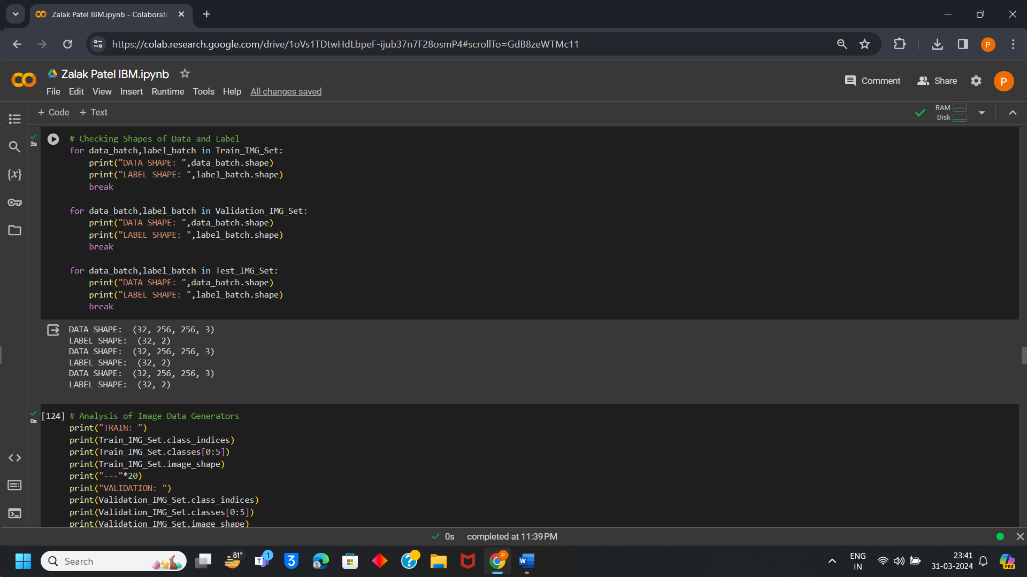

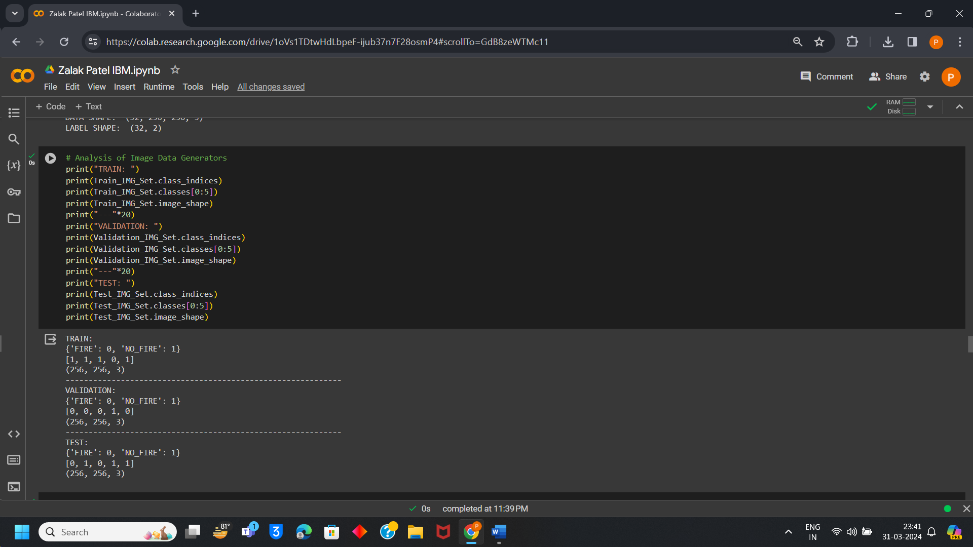

# Model Implementation:

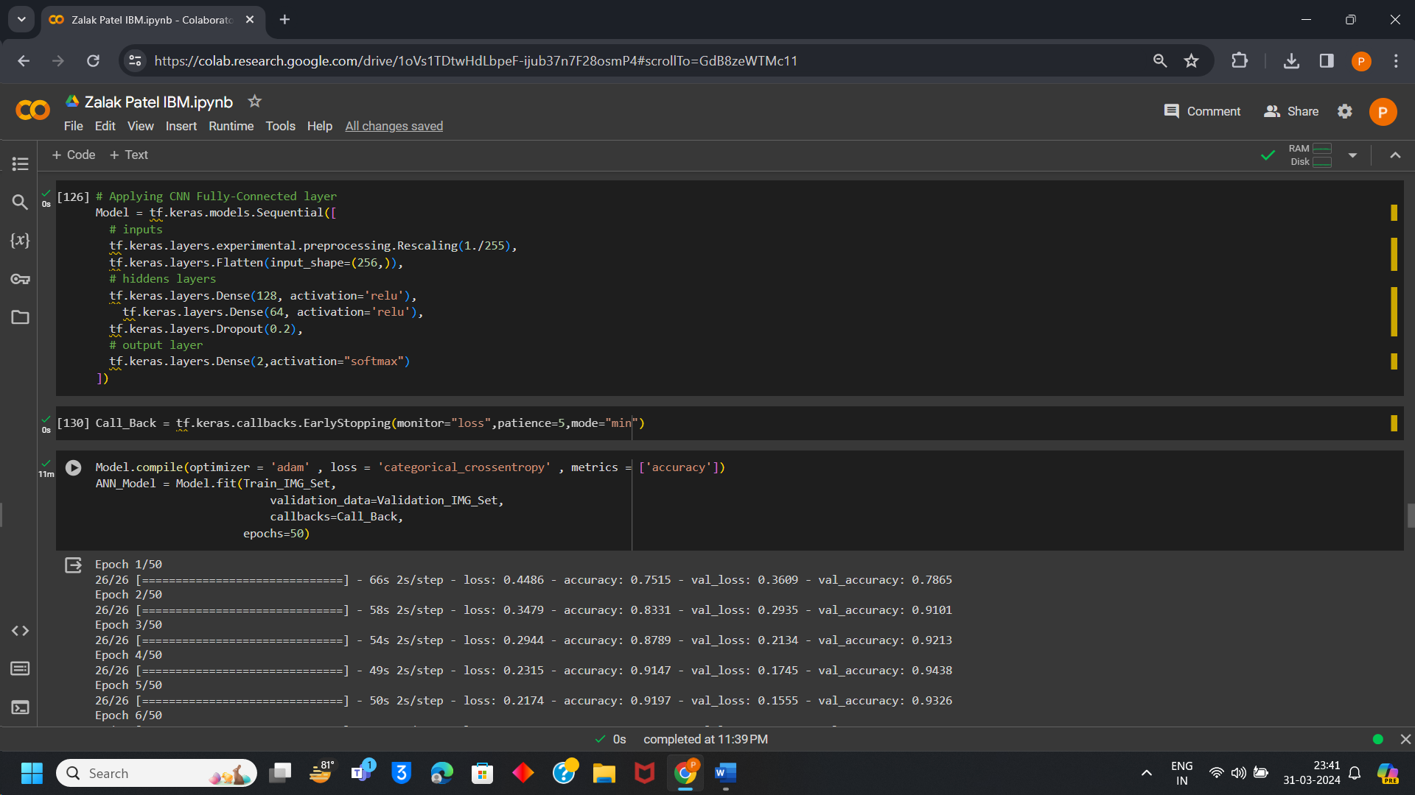

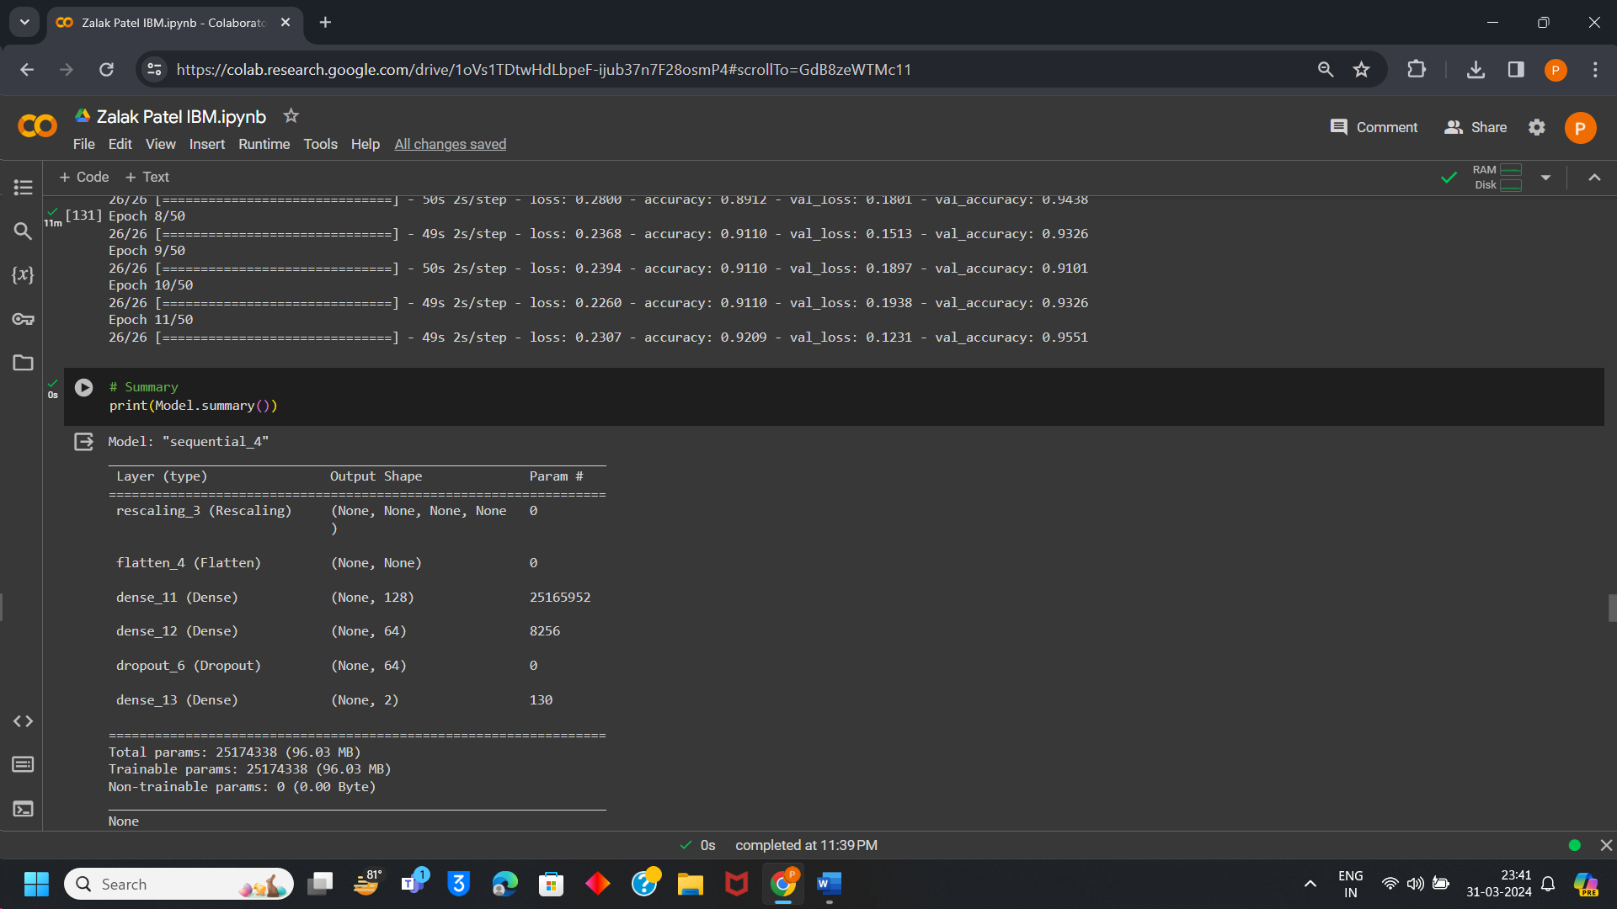

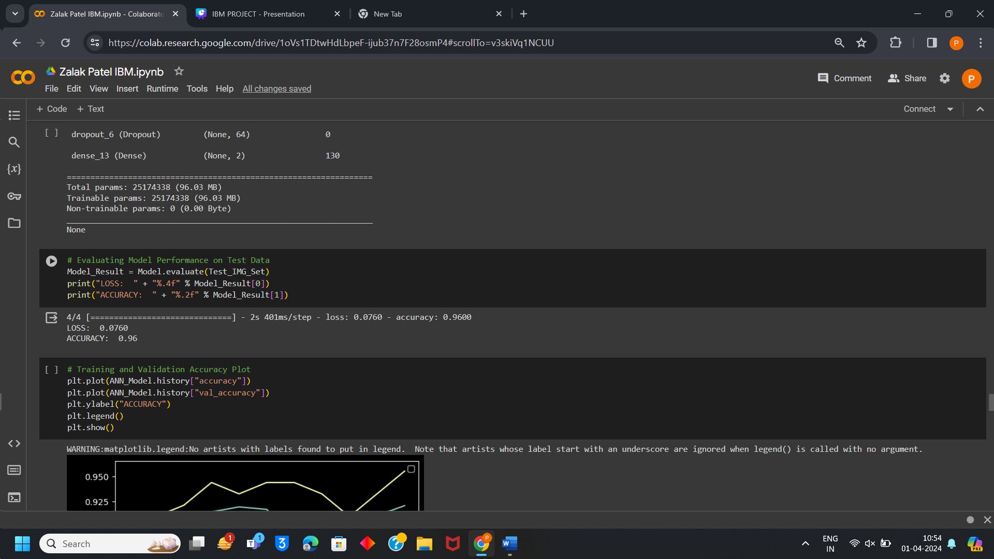

**Accuracy and Loss Plot:**

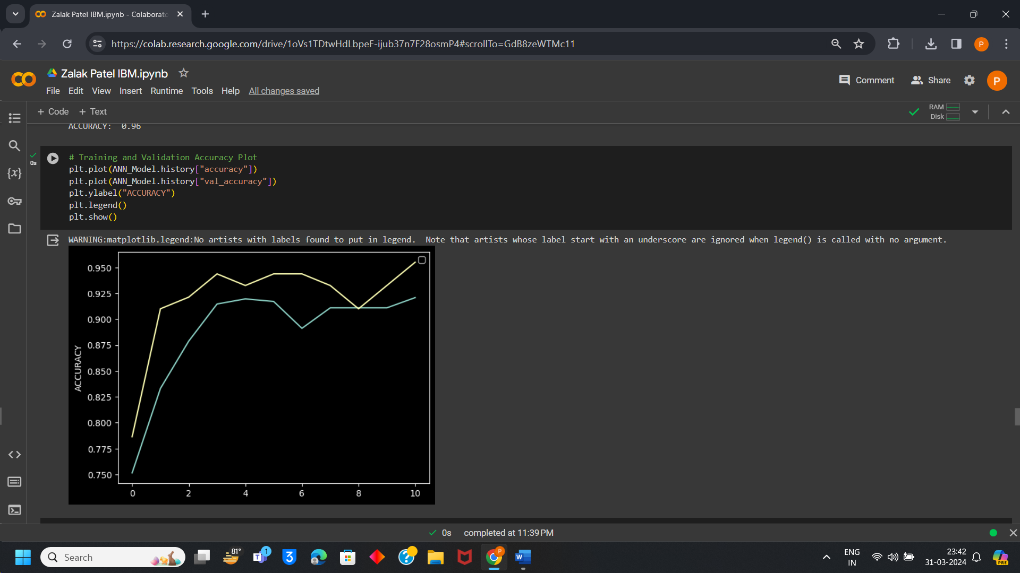

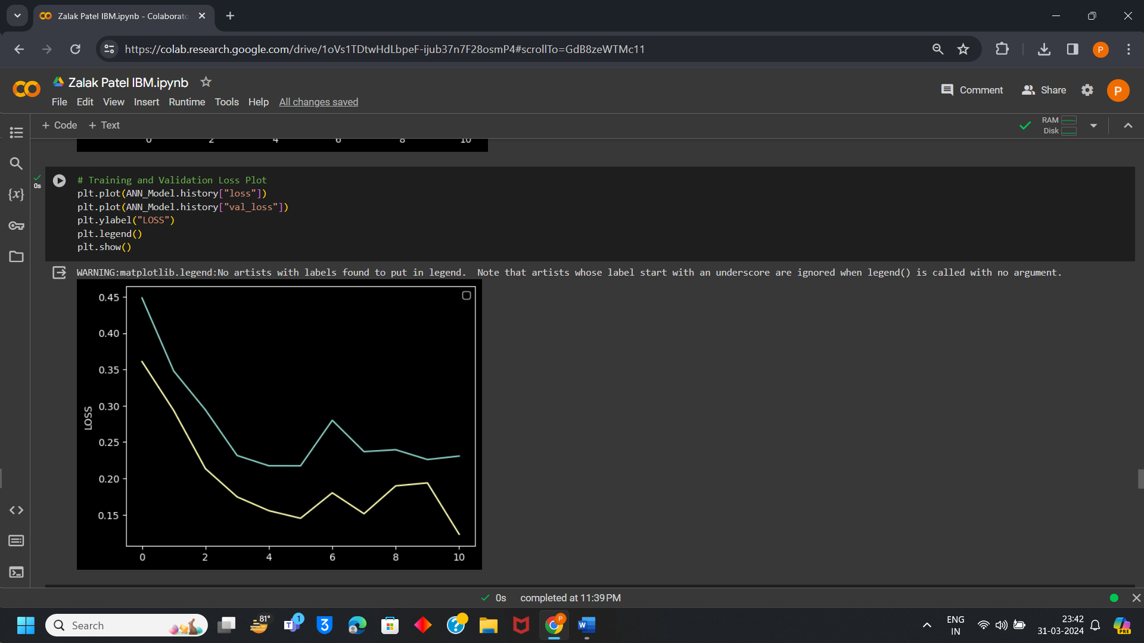

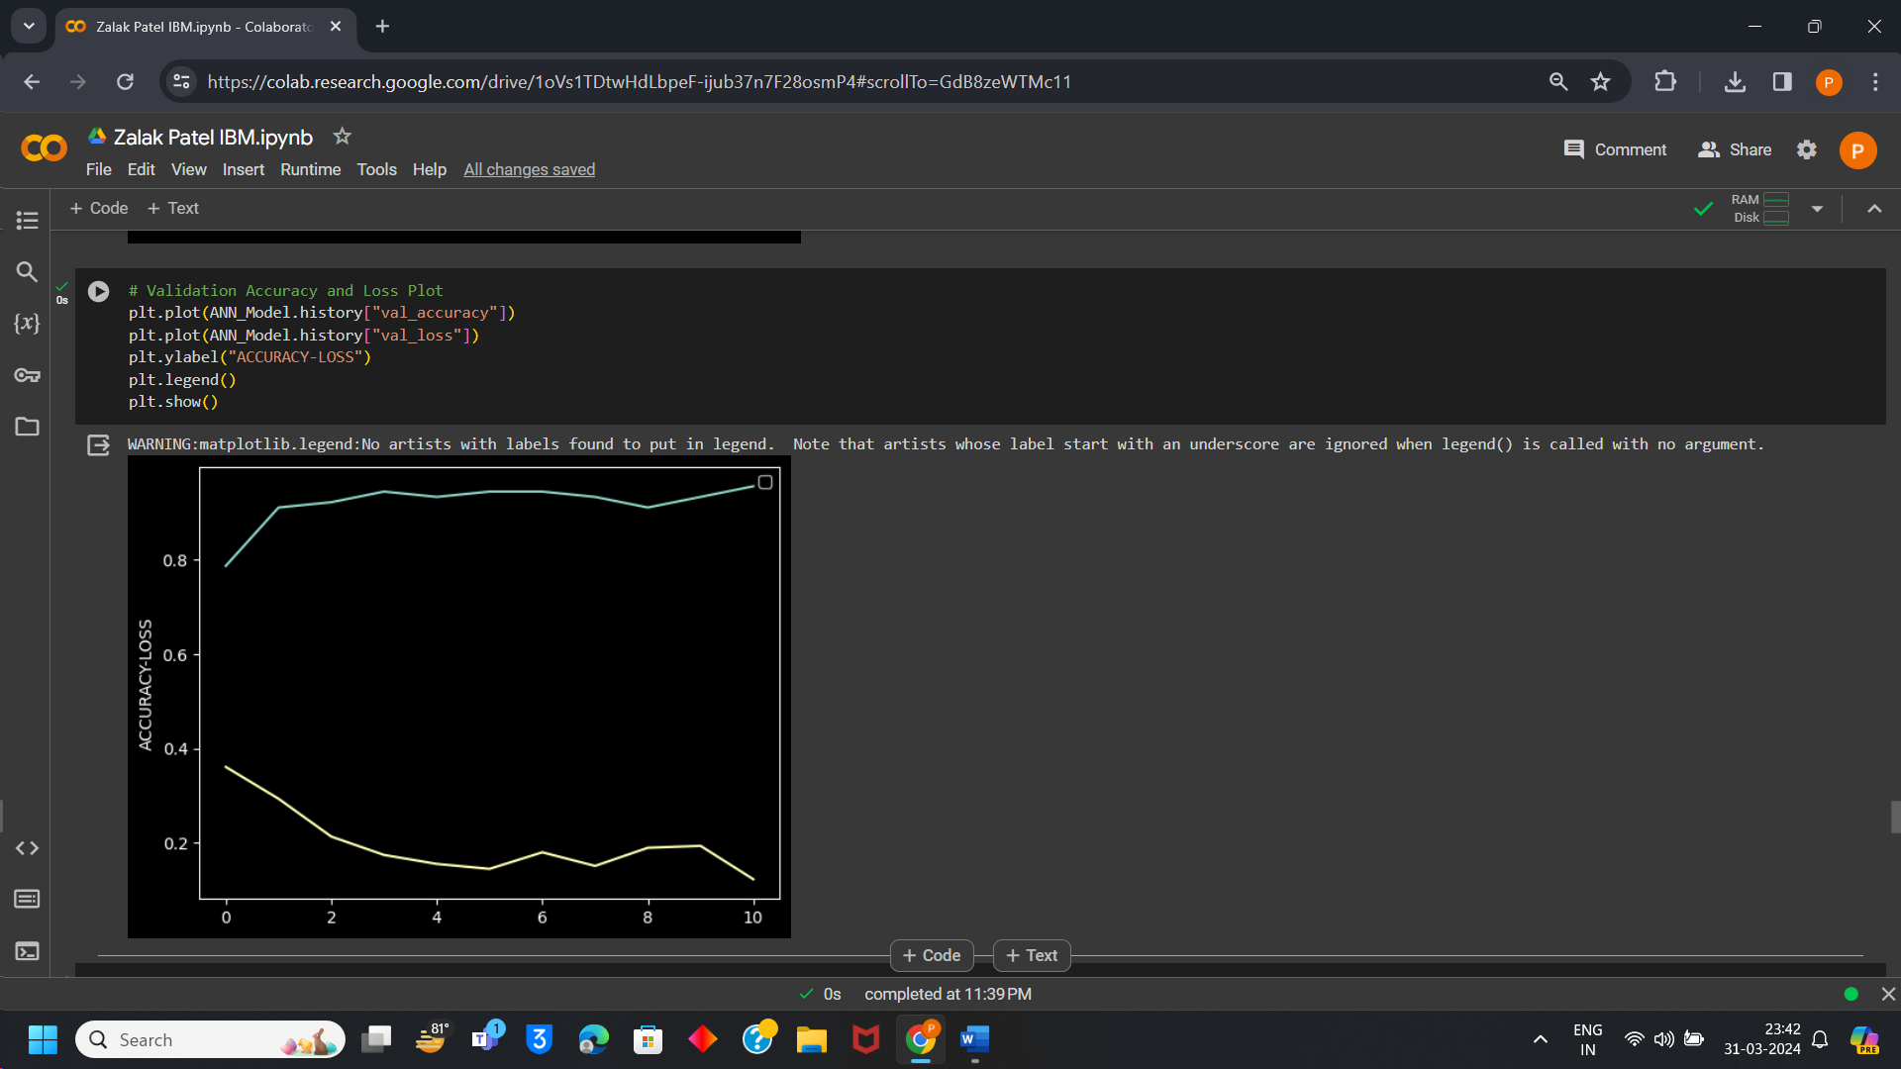

**Prediction and Evaluation Metrics:**

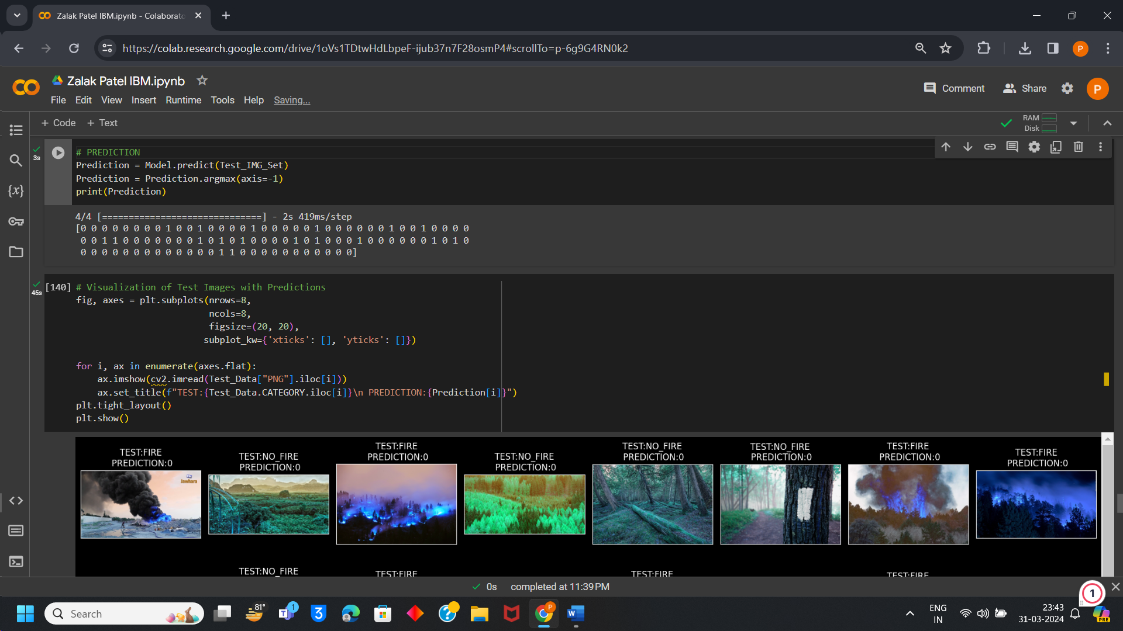

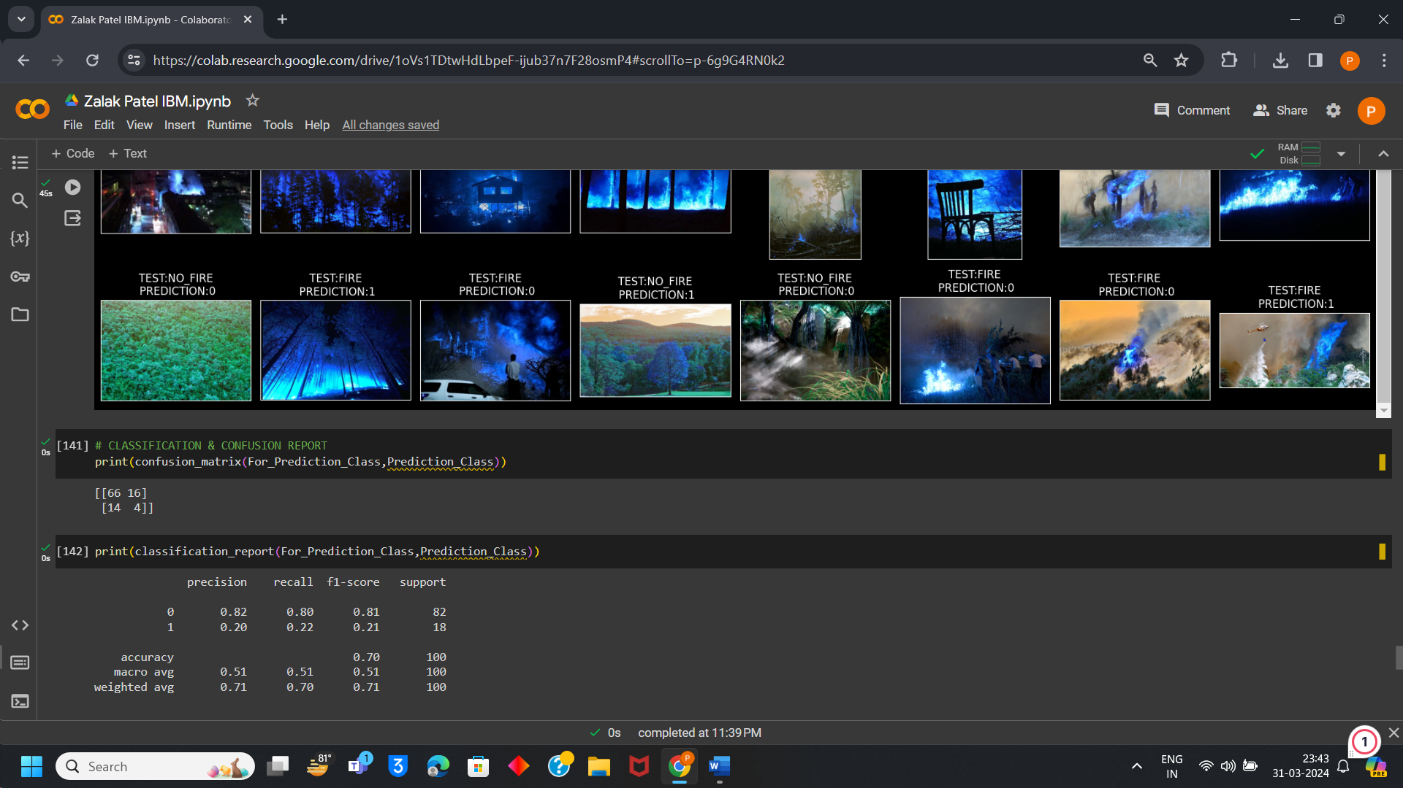

**Prediction on unseen data:**

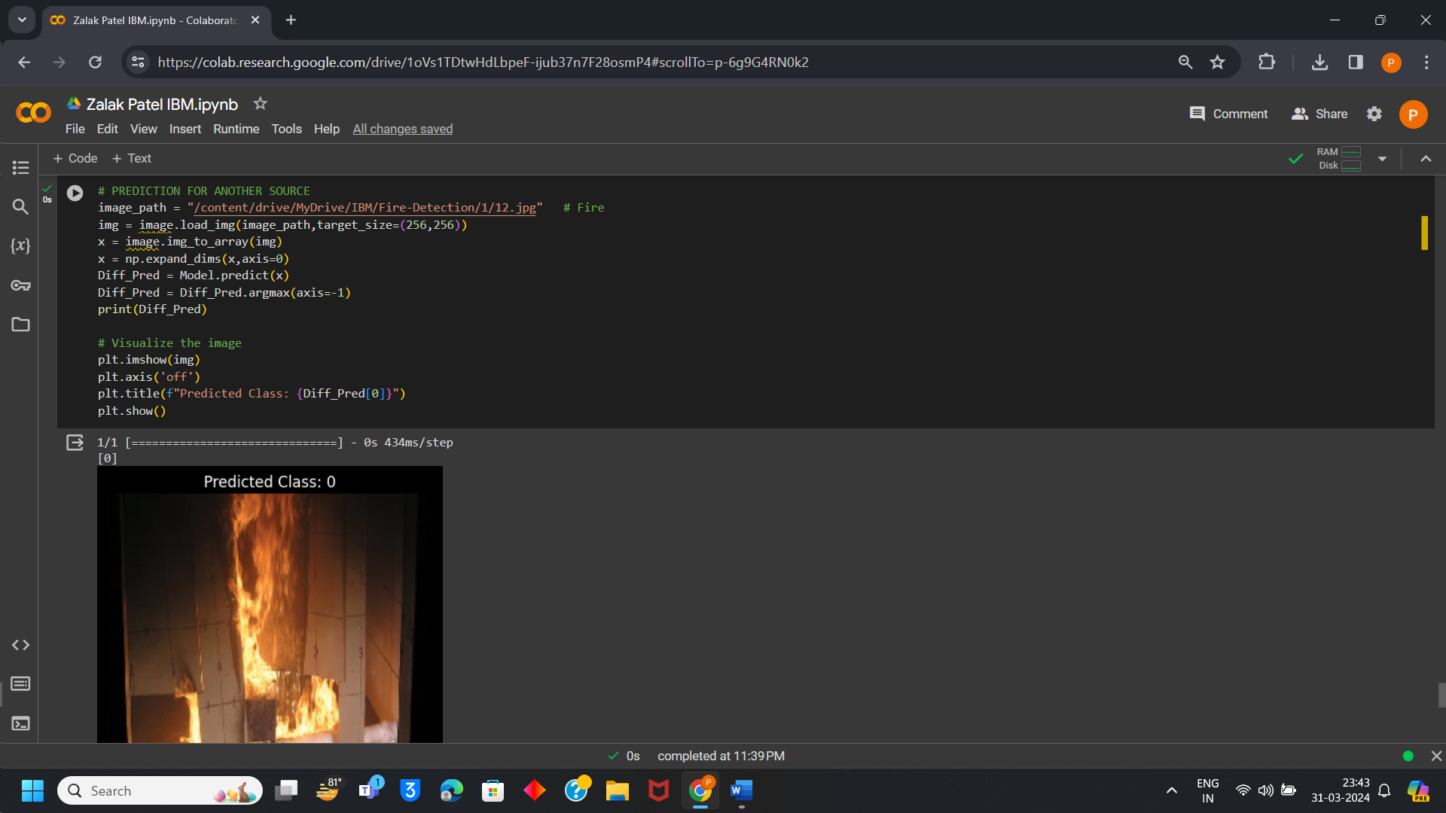

**Prediction on unseen data:**

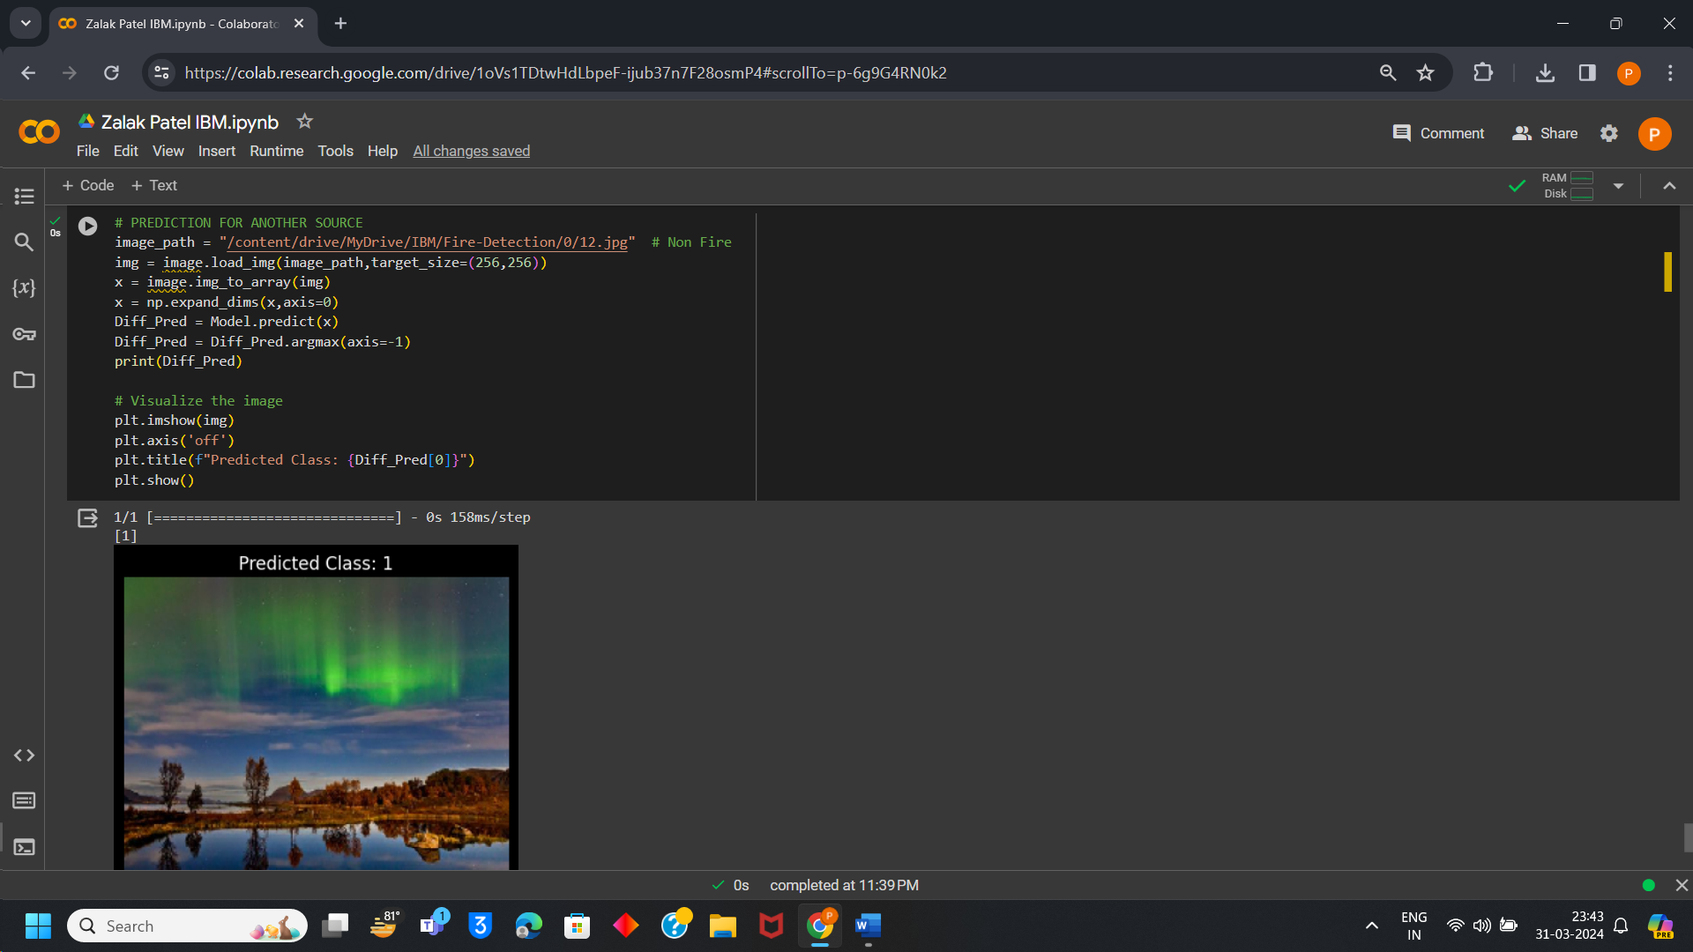

# Conclusion:

This Prediction is performed using a Fully-Connected Layer in a Convolutional Neural Network which is part of Machine Learning. Forest Fire Prediction has 96 % accuracy in predicting forest fires by visualizing images. This model is prepared and can work accurately even on unseen data.